**Deliverable 2**

Software Requirements Specification



**For**

***One Stop Degree Issuance System***

**Prepared by:**

* **Ali Umer (21I-0380)**
* **Umair Khalid (21I-0455)**
* **Abdullah Khan (20P-0100)**

**April 7, 2024.**

**Table of Contents:**

1. Revision History 5

2. Introduction: 5

2.1 Purpose: 5

2.2 Document Conventions: 5

2.3 Intended Audience and Reading Suggestions: 6

2.4 Product Scope: 6

2.5 References: 6

3. Overall Description: 6

3.1 Product Perspective: 6

3.2 Product Functions: 7

3.3 User Classes and Characteristics: 8

3.4 Operating Environment: 9

3.5 Design and Implementation Constraints: 9

4. User Stories: 9

5. System Features: 17

5.1 Feature Name: *Submit Degree Issuance Form* 17

5.1.1 Description and Priority: (High) 17

5.1.2 Stimulus/Response Sequences 17

5.1.3 Functional Requirements 17

5.2 Feature Name: *Submit Student Complaint Forms* 17

5.2.1 Description and Priority: (High) 17

5.2.2 Stimulus/Response Sequences 18

5.2.3 Functional Requirements 18

5.3 Feature Name: *Track Activity* 18

5.3.1 Description and Priority: (Low) 18

5.3.2 Stimulus/Response Sequences 18

5.3.3 Functional Requirements 18

5.4 Feature Name: *Generate Degree* 19

5.4.1 Description and Priority: (High) 19

5.4.2 Stimulus/Response Sequences 19

5.4.3 Functional Requirements 19

5.5 Feature Name: *Submit Student Data Change Form* 19

5.5.1 Description and Priority: (Normal) 19

5.5.2 Stimulus/Response Sequences 20

5.5.3 Functional Requirements 20

5.6 Feature Name: *Submit Student Feedback* 20

5.6.1 Description and Priority: (Low) 20

5.6.2 Stimulus/Response Sequences 20

5.6.3 Functional Requirements 20

5.7 Feature Name: *Receive Student Notification for Degree Issuance.* 21

5.7.1 Description and Priority: (High) 21

5.7.2 Stimulus/Response Sequences 21

5.7.3 Functional Requirements 21

5.8 Feature Name: *Process Request* 21

5.8.1 Description and Priority: (High) 21

5.8.2 Stimulus/Response Sequences 22

5.8.3 Functional Requirements 22

5.9 Feature Name: *Process User Complaints* 22

5.9.1 Description and Priority: (Normal) 22

5.9.2 Stimulus/Response Sequences 22

5.9.3 Functional Requirements 22

5.10 Feature Name: *View Requests Stats* 23

5.10.1 Description and Priority: (Low) 23

5.10.2 Stimulus/Response Sequences 23

5.10.3 Functional Requirements 23

5.11 Feature Name: *Generate Ineligible Students List* 23

5.11.1 Description and Priority: (Low) 23

5.11.2 Stimulus/Response Sequences 23

5.11.3 Functional Requirements 23

*5.12* Feature Name: *Check Outstanding Dues* 24

5.12.1 Description and Priority: (Normal) 24

5.12.2 Stimulus/Response Sequences 24

5.12.3 Functional Requirements 24

5.13 Feature Name: *Check Degree Issuance Fee Status* 24

5.13.1 Description and Priority: (Normal) 24

5.13.2 Stimulus/Response Sequences 24

5.13.3 Functional Requirements 25

5.14 Feature Name: *Generate Outstanding Dues List* 25

5.14.1 Description and Priority: (Low) 25

5.14.2 Stimulus/Response Sequences 25

5.14.3 Functional Requirements 25

5.15 Feature Name: *Generate Tokens* 25

5.15.1 Description and Priority: (High) 25

5.15.2 Stimulus/Response Sequences 26

5.15.3 Functional Requirements 26

5.16 Feature Name: *View Requests Log* 26

5.16.1 Description and Priority: (Low) 26

5.16.2 Stimulus/Response Sequences 26

5.16.3 Functional Requirements 26

*5.17* Feature Name: *Issue Degree* 27

5.17.1 Description and Priority: (High) 27

5.17.2 Stimulus/Response Sequences 27

5.17.3 Functional Requirements 27

5.18 Feature Name: *Issue Transcript* 27

5.18.1 Description and Priority: (High) 27

5.18.2 Stimulus/Response Sequences 27

5.18.3 Functional Requirements 27

5.19 Feature Name: *Update Student Data* 28

5.19.1 Description and Priority: (Normal) 28

5.19.2 Stimulus/Response Sequences 28

5.19.3 Functional Requirements 28

5.20 Feature Name: *Notify Complaint Result* 28

5.20.1 Description and Priority: (Normal) 28

5.20.2 Stimulus/Response Sequences 29

5.20.3 Functional Requirements 29

5.21 Feature Name: *View Department Stats* 29

5.21.1 Description and Priority: (Low) 29

5.21.2 Stimulus/Response Sequences 29

5.21.3 Functional Requirements 29

5.22 Feature Name: *View Feedback* 30

5.22.1 Description and Priority: (Low) 30

5.22.2 Stimulus/Response Sequences 30

5.22.3 Functional Requirements 30

5.23 Feature Name: *View Complaint Forms* 30

5.23.1 Description and Priority: (Low) 30

5.23.2 Stimulus/Response Sequences 30

5.23.3 Functional Requirements 30

6. Other Non-Functional Requirements: 31

6.1 Software Quality Attributes: 31

6.2 Performance Requirements: 31

6.3 Security Requirements: 31

7. User Interfaces: 31

8. Diagrams: 33

8.1 Class Diagram: 33

8.2 Use Case Diagram: 34

8.3 Activity Diagram: 35

8.4 Sequence Diagram: 38

8.4.1 Submit Degree Issuance Form 38

8.4.2 Receive Degree Issuance Form 39

8.4.3 Outstanding Fee 40

9. Links: 41

10. Snapshots: 41

10.1 Snapshot 1 41

10.2 Snapshot 2 42

10.3 Snapshot 3 42

10.4 Snapshot 4 43

# Revision History

|  |  |  |  |
| --- | --- | --- | --- |
| **Name** | **Date** | **Reason For Changes** | **Version** |
| Increment 1 | 7th April,2024 | The creation of an SRS Document for this software | V.1.0 |
|  |  |  |  |

# Introduction:

## Purpose:

This document talks about the Software Requirement Specifications for the One Stop Degree Issuance System. The current version is **V1.0**. This software is mainly an addition in the Fast University’s main portal to facilitate the students who are interested in sending a degree issuance request to the university’s administration and submit a form to generate their degree after their graduation. This system eradicates the need to physically visit the One Stop Office and converts the entire process into an online one. This document is for the whole Degree Issuance System, not just one part of it and is a guide to make sure the system does everything it needs to do.

## Document Conventions:

**Headings**: Times

**Paragraphs**: Times

**Font Size**: 18 (Main Headings), 14 (Sub-Headings) ,12 (Paragraphs).

**Note:** The higher-level requirements are assumed to be inherited by detailed requirements, and every requirement statement has its own priority.

## Intended Audience and Reading Suggestions:

This document is intended to be read by the entire team working on this project including the all the stakeholders, developers, testers, scrum master and product owner. The current document is to be read in a sequence from top to bottom and contains the product’s introduction, scope, description, requirements, interfaces and all other software artifacts.

## Product Scope:

The One Stop Degree Issuance System, as described in this document, is an addition in the Fast University’s main portal to facilitate the students who are interested in sending a degree issuance request to the university’s administration. This software facilitates the students who want to submit a form to generate their degree after their graduation. The main scope of this software covers interested students, (Admin, FYP and Finance Department), along with director to view and maintain the optimal working of this software. The main purpose for the creation of this software was to eradicates the need to physically visit the One Stop Office and convert the entire Degree Issuance Process into an online one.

## References:

**GitHub:**

<https://github.com/umairkhalidx/One-Stop-Degree-Issuance-System>

**Trello:**

<https://trello.com/invite/b/fq1hALcF/ATTI214e92d71c4b1df886a6b3c5d5b719ff4DD7B935/one-stop-degree-issuance-system>

# Overall Description:

## Product Perspective:

In context to the origin of One Stop Degree Issuance System, this software is an addition in the Fast University’s main portal and is a small part of the University’s main Portal. All the artifacts required for the creating and working of this software are listed further in this document.

## Product Functions:

1. **Submit Degree Issuance Form:** Students can submit their Degree Issuance Form.
2. **Submit Student Complaint Forms:** Students can report their issues by submitting a Student Complaint Forms.
3. **Track Activity:** Students can monitor the progress of their submitted requests.
4. **Generate Degree:** Once all the Processes are completed the students can Generate their degrees.
5. **Submit Student Data Update Form:** Students can submit their Data Update Form.
6. **Submit Student Feedback:** Students can submit their feedback form to provide their feedback on the performance of the system.
7. **Receive Student Notification for Degree Issuance:** Concerned Department can receive Student’s Notification for Degree Issuance.
8. **Process Requests:** Concerned Department can Process Student’s Request.
9. **Process User Complaints:** Concerned Department can Process Student’s Complaint.
10. **View Requests Stats:** Concerned Department can view stats regarding students’ requests.
11. **Generate Ineligible Students List:** FYP Department can Generate Ineligible Students List.
12. **Generate Outstanding Dues List:** Finance Department can Generate Outstanding Dues List.
13. **Check Outstanding Dues:** Finance Department can check Outstanding Dues List.
14. **Check Degree Issuance Fee Status:** Finance Department can check Degree Issuance Fee Status.
15. **Generate Tokens:** Administration Department can generate Token for Students Request.
16. **View Requests Log:** Concerned Department can view requests logs.
17. **Respond to Request:** Concerned Department can provide response to Students Request.
18. **Issue Degree:** Administration Department can generate Students Degree.
19. **Issue Transcript:** Administration Department can issue student’s transcript.
20. **Update Student Data:** Administration Department can update students’ data.
21. **Notify Complaint Result:** Administration Department can notify student about their submitted complaint.
22. **View Department Stats:** Director can view department stats.
23. **View Feedback:** Director can view students’ feedback.
24. **View Complaint Forms:** Director can view students’ complaint forms.
25. **UI in compliance with Flex Template:** The User Interface of this software is in accordance with the template of University’s main Student Portal.
26. **Remote Accessibility:** This system is remotely accessible to students through mobile, pc and laptop.

## User Classes and Characteristics:

The User Classes intended to use this software include:

* Graduated Students.
* Administration Department.
* FYP Department.
* Finance Department.
* Director the University.

**Note:** This software provides and public access to the graduated students and a private/protected access to the Director, Administration, FYP and Finance Department.

## Operating Environment:

This system is intended to be an addition in the University Online Web Portal and is fully functional and accessible on the web via a browser ensuring an Online Access from hardware platforms including Mobile Devices, Personal Computers and Laptops.

## Design and Implementation Constraints:

**Corporate Limitations:**

* The software should follow all the policies and regulations set forth by the universities administration.

**Hardware Limitations:**

* The software should be accessible on light weight mobile and laptop devices via a web browser.

**Software Limitations:**

* This software is to be only accessed and operated via Web Portal.
* The software’s UI must in accordance with the University’s Main UI Interface.
* The software is to be developed in C# with integrated ASP.Net.
* The IDE of Choice for the Development of this software is Visual Studio and Visual Studio Code.
* The software should specifically follow a version of SQL as the primary database.

# User Stories:

**Feature Name:** *Submit Degree Issuance Form*

**User Story:** As a Student, I want to submit my Degree Issuance Form, so that I can request the university administration to start the process of my degree issuance.

**Acceptance Criteria:** Given that the Degree Issuance Form is accessible by the students, when a student submits the form, then the university administration should initiate the Degree Issuance process.

**Feature Name:** *Submit Student Complaint Forms*

**User Story:** As a Student, I want to fill a Complaint Form, so that I can file my desired complaint to the university administration regarding my degree issuance process.

**Acceptance Criteria:** Given that the Complaint Form is accessible to the students, when a student fills out and submits the form, then the university administration should receive the complaint and take necessary actions.

**Feature Name:** *Track Activity*

**User Story:** As a Student, I want to track my Generated Requests, so that I stay updated about my Degree Issuance process.

**Acceptance Criteria:** Given an activity tracking system for the student, when a student enters their request details (for example token ID), then the system should provide updates on the status of their request.

**Feature Name:** *Generate Degree*

**User Story:** As a Student, I want the university administration to generate my degree, so that I can receive my degree on the Degree Issuance Portal.

**Acceptance Criteria:** Given a degree issuance portal, when a student’s Degree Issuance request is completed and degree is generated by the university administration, then the student should be able to view and download the degree from the portal.

**Feature Name:** *Submit Student Data Change Form*

**User Story:** As a Student, I want to submit my Student’s Data Change Form, so that I provide the university administration with my updated data that has been requested for a change.

**Acceptance Criteria:** Given a student’s data change form is accessible to the students, when a student fills out and submits the form, then the university should receive the form and process the request accordingly.

**Feature Name:** *Submit Student Feedback*

**User Story:** As a Student, I want to submit my Feedback Form, so that I can provide my comments regarding the usability of this system.

**Acceptance Criteria:** Given a student has completed the Degree Issuance process and received the degree by the university administration on the portal, when a student submits their feedback form regarding the usability of the system, then the administration and director should receive the feedback to review the feedback for further improvements in the system.

**Feature Name:** *Receive Student Notification for Degree Issuance.*

**User Story:** As a Member of the FYP Department, I want to receive student’s Notification for Degree Issuance from the administration, so that I can address the student’s request for Degree Issuance related to the Finance Department.

**Acceptance Criteria:** Given a notification system for FYP department and a student has submitted the degree issuance request, when the One Stop Admin forwards the student’s degree issuance form to the FYP Department, then the FYP department should receive the student’s Degree Issuance Form.

**Feature Name:** *Process Request*

**User Story:** As a Member of the FYP Department, I want to provide my decision regarding the student’s request, so that I can reply back to the student’s request as accepted, rejected or objection.

**Acceptance Criteria:** Given a system for degree issuance, when a member of the FYP department processes a student’s request, then the member should be able to reply back to the student using comments, informing them about the status of their pending request for degree issuance as accepted, rejected or objection.

**Feature Name:** *Process User Complaints*

**User Story:** As a Member of the FYP Department, I want to receive student complaints, so that I can resolve the complaints and reply back to the concerned.

**Acceptance Criteria:** Given a system for managing student’s complaints, when a member of the FYP department receives a student complaint, then the member should be able to take necessary actions to resolve the received complaint.

**Feature Name:** *View Requests Stats*

**User Story:** As a Member of the FYP Department, I want to View Requests Stats, so that I can analyze the time taken by the FYP committee to process a request.

**Acceptance Criteria:** Given a request inquiry system, when a member of the FYP department requests to view the statistics, then system should provide data on the time taken by FYP department to process each request.

**Feature Name:** *Generate Ineligible Students List*

**User Story:** As a Member of the FYP Department, I want to Generate an Ineligible Students List, so that I can notify all the students that are ineligible for Degree Issuance due to issues in their final year project.

**Acceptance Criteria:** Given a system to generate ineligible students list, when a member of FYP department requests a list of students who are ineligible for Degree Issuance due to issue in the Final Year Project, the system should provide a list of all ineligible students due to issues in their final year project.

**Feature Name:** *Receive Student Notification for Degree Issuance.*

**User Story:** As a Member of the Finance Department, I want to receive student’s Notification for Degree Issuance from the administration, so that I can address the student’s request for Degree Issuance related to the Finance Department.

**Acceptance Criteria:** Given a notification system for Finance department and a student has submitted the degree issuance request, when the One Stop Admin forwards the student’s degree issuance form to the Finance Department, then the Finance department should receive the student’s Degree Issuance Form.

**Feature Name:** *Check Outstanding Dues*

**User Story:** As a Member of the Finance Department, I want to view students’ fee details, so that I can check whether all the outstanding dues have been paid or not.

**Acceptance Criteria:** Given a system for finance department, when a member of the Finance Department requests to check a student’s financial details, then the system should provide the member with all the financial details of the students so that the member can check whether students has paid all their outstanding dues or not.

**Feature Name:** *Check Degree Issuance Fee Status*

**User Story:** As a Member of the Finance Department, I want to check student’s degree issuance fee status, so that I can check whether the student has paid the degree issuance fee or not.

**Acceptance Criteria:** Given a system for finance department, when a member of the finance department clicks on the check status button for student’s fee for degree issuance, then the system should provide the fee status for degree issuance of that student.

**Feature Name:** *Process Request*

**User Story:** As a Member of the Finance Department, I want to provide my decision regarding the student’s request, so that I can reply back to the student’s request as accepted, rejected or objection.

**Acceptance Criteria:** Given a system for degree issuance, when a member of the Finance department processes a student’s request, then the member should be able to reply back to the student using comments, informing them about the status of their pending request for degree issuance as accepted, rejected or objection.

**Feature Name:** *Generate Outstanding Dues List*

**User Story:** As a Member of the Finance Department, I want to Generate an Outstanding Dues List, so that I can notify all the students that are ineligible for Degree Issuance because they have encountered an issue related to the clearance of their remaining dues.

**Acceptance Criteria:** Given a finance system for finance department, when a member of the finance department requests the list of students with outstanding dues, then the system should provide the finance department with a list of all the students with outstanding dues.

**Feature Name:** *Receive Student Notification for Degree Issuance.*

**User Story:** As an Admin, I want to receive student’s notification for Degree Issuance, so that I can address the student’s request of Degree Issuance related to Finance Department.

**Acceptance Criteria**: Given a notification system for One Stop Admin, when a student submits his degree issuance request, then the One Stop Admin should receive the student’s notification of degree issuance request.

**Feature Name:** *Generate Tokens*

**User Story:** As an Admin, I want to Generate a Token, so that I can assign a unique id and required time for every student’s request.

**Acceptance Criteria**: Given a token generating system for One Stop Admin, when the One Stop Admin requests a token to assign it to a student’s request, then the system should provide unique number or ticket in ascending order and provide an option to set required time.

**Feature Name:** *View Requests Log*

**User Story:** As an Admin, I want to view the Requests Log, so that I can view all the requests received from the students that are either processed, pending or in new state.

**Acceptance Criteria**: Given a requests log system for the One Stop Admin, when the admin requests to see the ‘request log’, then the system should display all the requests received from students that are either processed, pending or in new state.

**Feature Name:** *Respond to Requests*

**User Story**: As an Admin, I want to reply to a student’s requests, so that I can inform the student about any objection on their request from the FYP or Finance Department.

**Acceptance Criteria**: Given a system for the admin to reply back to students’ requests, when the FYP or Finance Department object’s regarding students’ requests, then the system should allow the admin to respond to students regarding the objection.

**Feature Name:** *Issue Degree*

**User Story**: As an Admin, I want to issue a degree, so that I can complete the student’s request for degree issuance and update the processed request list.

**Acceptance Criteria**: Given a system to issue a degree by the One Stop Admin and the details of student in the Degree Issuance Form are correct and there are no objections from the FYP and Finance Department related to the student’s Degree Issuance Form, when the One Stop Admin request to issue a degree to a student, then the system should generate the degree of that student and update the process requests.

**Feature Name:** *Issue Transcript*

**User Story**: As an Admin, I want to issue a student’s transcript, so that I can provide the student with his/her transcript containing their department, CGPA, all courses’ grades, duration and photograph.

**Acceptance Criteria**: Given a system to issue a student’s transcript and the details of student’s grade in system are correct, when the One Stop Admin requests to issue a transcript of a student, then the system should generate the transcript with his/her department, courses with respective grades, duration and photograph.

**Feature Name:** *Update Student Data*

**User Story**: As an Admin, I want to receive student’s data change request form, so that I can update the student’s data that was previously incorrect.

**Acceptance Criteria**: Given a student submits a data change request form, when the One Stop Admin enters the updated data of certain student, then the system should update the data of that student.

**Feature Name:** *Notify Complaint Result*

**User Story:** As an Admin, I want to notify the student of their complaint result, so that I update the student on the outcome of their submitted complaint.

**Acceptance Criteria**: Given a complain system for the One Stop Admin, when the admin receives the results of the complaint submitted by the student, then the admin should be able to notify the students regarding their complaint.

**Feature Name:** *View Requests Log*

**User Story:** As a Director, I want to view the Requests Log, so that I can view all the requests that were generated on a certain day.

**Acceptance Criteria**: Given a requests log system for the director, when the director requests to view the request log and sets a filter on the basis of a particular day, then the system should show all the request generated on that day.

**Feature Name:** *Pending requests*

**User Story:** As a Director, I want to view the Requests Log, so that I can view all the students’ requests that are in the pending state.

**Acceptance Criteria**: Given a requests log system for the director, when the director requests to view the request logs and sets the filter to pending, then the system should display all the requests that are in the pending state.

**Feature Name:** *Processed request*

**User Story:** As a Director, I want to view the Requests Log, so that I can view all the students’ requests that are in processed state.

**Acceptance Criteria**: Given a requests log system for the director, when the director requests to view the requests log and sets the filter to processed, then the system should display all the requests that are in the processed state.

**Feature Name:** *Track Activity*

**User Story:** As a Director, I want to track a certain request, so that I can view the status of that request and check in which department the current request is being processed.

**Acceptance Criteria**: Given an activity tracking system for the director and the Director is viewing the Requests Log, when the director request details of a certain requests, then the system should display all the related details of the request.

**Feature Name:** *View Department Stats*

**User Story:** As a Director, I want to View the Request Stats, so that I can analyze the time taken by each department to process the requests.

**Acceptance Criteria**: Given a requests log system for the director and the Director is viewing the Requests Log , when the director requests the departments statistics to analyze the performance of each department, then the system should display all the department stats based on the time taken by each department to process their respective requests.

**Feature Name:** *View Feedback*

**User Story:** As a Director, I want to view the submitted feedbacks, so that I check what are the views of students regarding the usability of this system.

**Acceptance Criteria**: Given a system to monitor feedback, when the director requests to view student feedbacks to analyze the views of students regarding the usability of this system, then the system should display all the feedbacks of all the students.

**Feature Name:** *View Complaint Forms*

**User Story:** As a Director, I want to View all the submitted Complaint Forms, so that I analyze what are the issues that students are currently facing regarding their degree issuance process.

**Acceptance Criteria**: Given a system to monitor complaints, when the director requests the complaints from of all the students, then the system should display all the complains submitted by the students.

**Feature Name:** *UI in compliance with Flex Template*

**User Story:** As a Director, I want the user-interface of this system to follow that same template as our main student portal, so that I guarantee that the entire system remains consistent and follows a fixed template.

**Acceptance Criteria**: Given a main student portal, when the new Degree Issuance Portal is completed, then the user-interface of this system should follow the same template as of our main student portal.

# System Features:

## Feature Name: *Submit Degree Issuance Form*

### Description and Priority: (High)

* This feature allows students to view, fill and submit a Degree Issuance Form so that they can send their request to administration for Degree Issuance.

### Stimulus/Response Sequences

1. Student has logged in using his credentials.
2. Student clicks on Degree Issuance Form Button.
3. System displays a Degree Issuance Form.
4. Student Fills the Degree Issuance Form.
5. Student Clicks on the Submit Button.
6. Systems Sends a Degree Issuance Request to the Administration.
7. System Redirects Student to Home Screen.

### Functional Requirements

* F-001: When a student clicks on the Degree Issuance Form Button then the System should display a degree issuance form to the student.
* The Degree Issuance Form should allow student to enter their Name, Roll Number, Batch and Department.
* F-002: When student clicks on the Submit Button in the Degree Issuance Form then the System should send a request to the administration for Degree Issuance with students submitted Degree Issuance Form.
* F-003: When Student clicks on the Submit Button in the Degree Issuance Form then the System should redirect the user to the Homepage.
* F-004: If any error occurs when the user clicks on the submit button then the System should redirect the user to the Homepage.

## Feature Name: *Submit Student Complaint Forms*

### Description and Priority: (High)

* This feature allows students to submit a Complaint Form so that they can report a problem to the administration.

### Stimulus/Response Sequences

1. Student has logged in using his credentials.
2. Student clicks on Complaint Form Button.
3. System displays a Complaint Form.
4. Student Fills the Complaint Form.
5. Student Clicks on the Submit Button.
6. Systems Sends the Complaint Form to the Administration.
7. System Redirects Student to Home Screen.

### Functional Requirements

* F-005: When a student clicks on the Complaint Button then the System should display a complaint form to the student.
* F-006: The Complaint Form should allow student to enter their Name, Roll Number, Batch and Department and Description of the complaint.
* F-007: When student clicks on the Submit Button in the Complaint Form then the System should send a request to the administration with students submitted Complaint Form.
* F-008: When Student clicks on the Submit Button in the Complaint Form then the System should redirect the user to the Homepage.
* F-009: If any error occurs when the user clicks on the submit button then the System should redirect the user to the Homepage.

## Feature Name: *Track Activity*

### Description and Priority: (Low)

* This feature allows students to view the current status of their submitted request.

### Stimulus/Response Sequences

1. Student has logged in using his credentials.
2. Student clicks on Track Activity Button.
3. System displays all the user Requests.
4. Student clicks on a Request.
5. Systems shows the current status of the request.

### Functional Requirements

* F-010: When a student clicks on the Track Activity Button then the System should display all the submitted request that student has submitted to the student.
* F-011: When Student click on a Request in the Track Activity Menu then the system should fetch the current status of the request and display it to the student.
* F-012: If any error occurs when the user clicks on the Track Activity Button then the System should redirect the user to the Homepage.

## Feature Name: *Generate Degree*

### Description and Priority: (High)

* This feature allows students to generate their respective degree after all the degree issuance processes have been completed.

### Stimulus/Response Sequences

1. Student has logged in using his credentials.
2. Student clicks on Generate Degree Button.
3. System checks if all the degree issuance form has been submitted.
4. System checks if the status has been approved.
5. If status has been approved then system generates the student degree.
6. If status has not been approved the system display an error message.
7. If degree has been generated then the student can view the degree on their dashboard.

### Functional Requirements

* F-013: When a student clicks on the Generate Degree Button then the system checks if the student has submitted the degree issuance form.
* F-014: When a student clicks on the Generate Degree Button then the system checks if the student’s degree issuance request’s status has been changed to approved or not.
* F-015: When the system checks if the student has submitted the Degree Issuance Form and the student has not submitted the form then the system should display a message “Kindly Submit the Degree Issuance Form First”.
* F-016: When the system checks the status of student’s Degree Issuance Form and the status has been approved then the system initializes the generate degree process.
* F-017: When the system checks the status of student’s Degree Issuance Form and the status has not been approved then the system should display a message “Error Occurred”.
* F-018: If any error occurs when the student clicks on the Generate Degree Button then the system should display a message “Error Occurred”.

## Feature Name: *Submit Student Data Change Form*

### Description and Priority: (Normal)

* This feature allows students to submit a Data Change Form to the Administration with their new credentials.

### Stimulus/Response Sequences

1. Student has logged in using his credentials.
2. Student clicks on Data Change Form Button.
3. System displays a Data Change Form.
4. Student Fills the Data Change Form.
5. Student Clicks on the Submit Button.
6. Systems Sends the Data Change Form to the Administration.
7. System Redirects Student to Home Screen.

### Functional Requirements

* F-019: When a student clicks on the Data Change Form Button then the System should display a Data Change Form to the student.
* F-020: The Data Change Form should allow student to enter their Name, Roll Number, Batch and Department.
* F-021: When student clicks on the Submit Button in the Data Change Form then the System should send a request to the administration with students submitted Data Change Form.
* F-022: When Student clicks on the Submit Button in the Data Change Form then the System should redirect the user to the Homepage.
* F-023: If any error occurs when the user clicks on the submit button then the System should redirect the user to the Homepage.

## Feature Name: *Submit Student Feedback*

### Description and Priority: (Low)

* This feature allows students to submit a Feedback Form to the Administration to provide their feedback on the working and performance of the Degree Issuance System.

### Stimulus/Response Sequences

1. Student has logged in using his credentials.
2. Student clicks on Feedback Form Button.
3. System displays a Feedback Form.
4. Student Fills the Feedback Form.
5. Student Clicks on the Submit Button.
6. Systems Sends the Feedback to the Administration.
7. System Redirects Student to Home Screen.

### Functional Requirements

* F-024: When a student clicks on the Feedback Form Button then the System should display a Feedback Form to the student.
* F-025: The Feedback Form should allow student to enter their Name, Roll Number, Batch and Department and Description of their feedback.
* F-026: When student clicks on the Submit Button in the Feedback Form then the System should send the students feedback to the administration.
* F-027: When Student clicks on the Submit Button in the Feedback Form then the System should redirect the user to the Homepage.
* F-028: If any error occurs when the user clicks on the submit button then the System should redirect the user to the Homepage.

## Feature Name: *Receive Student Notification for Degree Issuance.*

### Description and Priority: (High)

* This feature allows Administration, FYP and Finance Department to receive the Student’s Request for Degree Issuance.

### Stimulus/Response Sequences

1. Student has logged in using his credentials.
2. Student clicks on Submit Button in the Degree Issuance Form.
3. System sends the student’s Degree Issuance Request to the Admin Department.
4. System sends the student’s Degree Issuance Request to the FYP Department.
5. System sends the student’s Degree Issuance Request to the Finance Department.

### Functional Requirements

* F-029: When a student clicks on the Submit Button in the Degree Issuance Form then the system should send the student’s degree issuance request to the Administration department along with student’s degree issuance form.
* F-030: When a student clicks on the Submit Button in the Degree Issuance Form then the system should send the student’s degree issuance request to the FYP department along with student’s degree issuance form.
* F-031: When a student clicks on the Submit Button in the Degree Issuance Form then the system should send the student’s degree issuance request to the Finance department along with student’s degree issuance form.
* F-032: If any error occurs when the user clicks on the submit button then the System should redirect the user to the Homepage.

## Feature Name: *Process Request*

### Description and Priority: (High)

* This feature allows Administration, FYP and Finance Department to process the received Student’s Request for Degree Issuance.

### Stimulus/Response Sequences

1. The Department’s Employee has logged in using his credentials.
2. The Employee click on View Requests Button.
3. The System displays the current student requests.
4. The Employee clicks on a student’s request.
5. The System allows to change the status of a student’s request.

### Functional Requirements

* F-033: When the employee of a department clicks on the View Requests Button then the system should fetch and display all the current students’ requests.
* F-034: When the employee of a department clicks on any student’s request then the system should allow the employee to change the current status of the student’s request.
* F-035: If any error occurs when the user clicks on the View Requests button then the system should display a message “Error Occurred”.

## Feature Name: *Process User Complaints*

### Description and Priority: (Normal)

* This feature allows Administration Department to process the received Student’s Complaints.

### Stimulus/Response Sequences

1. The Department’s Employee has logged in using his credentials.
2. The Employee click on View Complaints Button.
3. The System displays the current student complaints.
4. The Employee clicks on a student’s complaint.
5. The System allows to change the status of a student’s request.

### Functional Requirements

* F-036: When the employee of a department clicks on the View Complaints Button then the system should fetch and display all the current students’ complaints.
* F-037: When the employee of a department clicks on any student’s complaint then the system should allow the employee to change the current status of the student’s complaint.
* F-038: If any error occurs when the user clicks on the View Complaints button then the system should display a message “Error Occurred”.

## Feature Name: *View Requests Stats*

### Description and Priority: (Low)

* This feature allows Administration Department to view the Requests Stats Log.

### Stimulus/Response Sequences

1. The Department’s Employee has logged in using his credentials.
2. The Employee click on View Requests Stats Button.
3. The System displays the Requests Stats Log.

### Functional Requirements

* F-039: When the employee of a department clicks on the View Requests Stats Button then the system should fetch and display the Requests Stats Log.
* F-040: If any error occurs when the user clicks on the View Requests Stats button then the system should display a message “Error Occurred”.

## Feature Name: *Generate Ineligible Students List*

### Description and Priority: (Low)

* This feature allows FYP Department to generate an Ineligible Students List that is automatically sent to all the students on their email.

### Stimulus/Response Sequences

1. The FYP Department’s Employee has logged in using his credentials.
2. The Employee click on Generate Ineligible Students List Button.
3. The System generates the Ineligible Students List.
4. The System sends the Ineligible Students List to all the students on their email.

### Functional Requirements

* F-041: When the employee of a department clicks on the Generate Ineligible Students List Button then the system should generate Ineligible Students List.
* F-042: When the System has generated the Ineligible Students List then the system should send all the students the Ineligible Students List on their email address.
* F-043: If any error occurs when the user clicks on the Generate Ineligible Students List button then the system should display a message “Error Occurred”.

## Feature Name: *Check Outstanding Dues*

### Description and Priority: (Normal)

* This feature allows Finance Department to check if a student has paid all their outstanding dues or not.

### Stimulus/Response Sequences

1. The Finance Department’s Employee has logged in using his credentials.
2. The Employee click on Check Outstanding Dues Button.
3. The System displays a Menu.
4. The Employee enters the students Roll Number.
5. The System returns the status of students outstanding dues as submitted or pending.

### Functional Requirements

* F-044: When the employee of a department clicks on the Check Outstanding Dues Button then the system should display a Check Outstanding Dues Menu that allows the employee to enter student’s roll number and check the status of their outstanding dues.
* F-045: When the employee enters the students roll number and clicks on check dues status then the system should return the status of students outstanding dues as submitted or pending.
* F-046: If any error occurs when the user clicks on the Check Outstanding Dues button then the system should display a message “Error Occurred”.

## Feature Name: *Check Degree Issuance Fee Status*

### Description and Priority: (Normal)

* This feature allows Finance Department to check if a student has paid all their degree issuance fees or not.

### Stimulus/Response Sequences

1. The Finance Department’s Employee has logged in using his credentials.
2. The Employee click on Check Degree Issuance Fee Status Button.
3. The System displays a Menu.
4. The Employee enters the students Roll Number.
5. The System returns the status of student’s degree issuance fee status as submitted or pending.

### Functional Requirements

* F-047: When the employee of a department clicks on the Check Degree Issuance Fee Status Button then the system should display a Check Degree Issuance Fee Status Menu that allows the employee to enter student’s roll number and check the status of their degree issuance fess.
* F-048: When the employee enters the students roll number and clicks on check degree issuance fee status then the system should return the status of student’s degree issuance fees as submitted or pending.
* F-049: If any error occurs when the user clicks on the Check Degree Issuance Fee Status button then the system should display a message “Error Occurred”.

## Feature Name: *Generate Outstanding Dues List*

### Description and Priority: (Low)

* This feature allows Finance Department to generate an Outstanding Dues List that is automatically sent to all the students on their email.

### Stimulus/Response Sequences

1. The Finance Department’s Employee has logged in using his credentials.
2. The Employee click on Generate Outstanding Dues List Button.
3. The System generates the Outstanding Dues List.
4. The System sends the Outstanding Dues List to all the students on their email.

### Functional Requirements

* F-050: When the employee of a department clicks on the Generate Outstanding Dues List Button then the system should generate Ineligible Students List.
* F-051: When the System has generated the Outstanding Dues List then the system should send all the students the Outstanding Dues List on their email address.
* F-052: If any error occurs when the user clicks on the Generate Outstanding Dues List button then the system should display a message “Error Occurred”.

## Feature Name: *Generate Tokens*

### Description and Priority: (High)

* This feature allows Administration Department to generate a unique token to assign to a student’s request for Degree Issuance.

### Stimulus/Response Sequences

1. The Administrations Department’s Employee has logged in using his credentials.
2. The Employee clicks on a student’s request.
3. Then the Employee click on Generate Unique Token Button.
4. The System generates a unique Token.
5. The Employee assigns that unique token to the student’s request.

### Functional Requirements

* F-053: When the employee of the administration department is viewing a student’s request and they click on the Generate Unique Token Button then the system should generate a unique token.
* F-054: When the employee clicks on the assign token then the system should assign the unique token to the selected students request.
* F-055: If any error occurs when the user clicks on the Generate Unique Token Button then the system should display a message “Error Occurred”.

## Feature Name: *View Requests Log*

### Description and Priority: (Low)

* This feature allows Director and Administration Department to view the Requests Log.

### Stimulus/Response Sequences

1. The Department’s Employee or Director has logged in using his credentials.
2. The Employee or the Director click on View Requests Logs Button.
3. The System displays the Requests Log.

### Functional Requirements

* F-056: When the employee of the administration department clicks on the View Requests Button then the system should fetch and display the Requests Log.
* F-057: When the Director clicks on the View Requests Button then the system should fetch and display the Requests Log.
* F-058: If any error occurs when the user clicks on the View Requests Stats button then the system should display a message “Error Occurred”.

## Feature Name: *Issue Degree*

### Description and Priority: (High)

This feature allows the director to generate student’s degree if the entire degree issuance process has been completed and the status of student’s degree issuance form has been set to approved.

### Stimulus/Response Sequences

1. Director has logged in using his credentials.
2. Director clicks on Generate Degree Button.
3. System checks if the status of the degree issuance has been set to approved.
4. If status has been approved then system generates the student degree.
5. If status has not been approved the system display an error message.

### Functional Requirements

* F-059: When the Director clicks on the Generate Degree Button then the system checks if the student has submitted the degree issuance form.
* F-060: When the Director clicks on the Generate Degree Button then the system checks if the student’s degree issuance request’s status has been changed to approved or not.
* F-061: When the system checks the status of student’s Degree Issuance Form and the status has been approved then the system initializes the generate degree process.
* F-062: When the system checks the status of student’s Degree Issuance Form and the status has not been approved then the system should display a message “Unable to Generate Degree”.
* F-063: If any error occurs when the Director clicks on the Generate Degree Button then the system should display a message “Error Occurred”.

## Feature Name: *Issue Transcript*

### Description and Priority: (High)

This feature allows the director of the university to generate specified student’s transcript.

### Stimulus/Response Sequences

1. Director has logged in using his credentials.
2. Director clicks on Generate Transcript Button.
3. System displays a Generate Transcript Menu.
4. Director enters the student’s Roll Number.
5. System generates the student’s transcript and send the transcript to the student on their email address.

### Functional Requirements

* F-064: When the Director clicks on the Generate Transcript Button then the system should display a generate transcript menu to the director that allows director to enter students roll number.
* F-065: When the Director enter the student’s roll number in the Generate Transcript menu and clicks the Generate Transcript Button then the system generates the student’s transcript.
* F-066: When the system has generated the student’s transcript then the system should send the student their transcript on their email address.
* F-067: If any error occurs when the user clicks on the Track Activity Button then the System should redirect the user to the Homepage.

## Feature Name: *Update Student Data*

### Description and Priority: (Normal)

This feature allows administration to update student’s data.

### Stimulus/Response Sequences

1. The employee of Administration Department has logged in using his credentials.
2. The employee clicks on Update Students Data Button.
3. System displays an Update Student’s Data Menu.
4. The employee enters the new student credentials.
5. The employee clicks on Update Data Button.
6. System updates the student’s data.

### Functional Requirements

* F-068: When the employee of administration department clicks on the Update Students Data Button then the system should display an Update Students Data Menu to the employee that allows the employee to enter student’s new credentials (Name, Roll Number, Batch, Department).
* F-069: When the Employee of Administration Department has entered the new credentials (Name, Roll Number, Batch, Department) and clicks the Update Students Data Button then the system should update the student’s data.
* F-070: If any error occurs when the user clicks on the Track Activity Button then the System should redirect the employee to the Homepage.

## Feature Name: *Notify Complaint Result*

### Description and Priority: (Normal)

This feature allows administration to notify the student about the result of their complaint.

### Stimulus/Response Sequences

1. The employee of Administration Department has logged in using his credentials.
2. The employee clicks on Notify Complaint Result Button.
3. System displays an Notify Complaint Result Menu.
4. The employee enters the student’s roll number and description.
5. The employee clicks on Notify Result Button.
6. System sends the complaint result to the respective student.

### Functional Requirements

* F-071: When the Employee of Administration Department clicks on the Notify Complaint Result Button then the system should display a Notify Complaint Result Menu to the employee that allows the employee to enter students roll number and complaint result description.
* F-072: When the Employee enters the student’s roll number and the complaint result description in the Notify Complaint Result Menu and clicks the Notify Result Button then the system sends the complaint result to the respective student.
* F-073: If any error occurs when the user clicks on the Notify Complaint Result Button then the system should display a message “Error Occurred”.

## Feature Name: *View Department Stats*

### Description and Priority: (Low)

The feature allows the Director of the university to view all the departments stats.

### Stimulus/Response Sequences

1. The Director of the university has logged in using his credentials.
2. The Director clicks on View Department Stats Button.
3. The System displays the Department Stats Log.

### Functional Requirements

* F-074: When the Director clicks on the View Department Stats Button then the system should fetch and display the Department Stats Log.
* F-075: If any error occurs when the user clicks on the View Department Stats button then the system should display a message “Error Occurred”.

## Feature Name: *View Feedback*

### Description and Priority: (Low)

The feature allows the Director of the university to view all the submitted students’ feedback.

### Stimulus/Response Sequences

1. The Director of the university has logged in using his credentials.
2. The Director clicks on View Feedback Button.
3. The System displays all the students’ submitted feedbacks.

### Functional Requirements

* F-076: When the Director clicks on the View Feedback Button then the system should fetch and display the students’ submitted Feedbacks.
* F-077: If any error occurs when the user clicks on the View Feedback Button then the system should display a message “Error Occurred”.

## Feature Name: *View Complaint Forms*

### Description and Priority: (Low)

The feature allows the Director of the university to view all the submitted complaint forms.

### Stimulus/Response Sequences

1. The Director of the university has logged in using his credentials.
2. The Director clicks on View Complaint Forms Button.
3. The System displays all the students’ submitted complaint forms.

### Functional Requirements

* F-078: When the Director clicks on the View Complaint Forms Button then the system should fetch and display the students’ submitted complaint forms.
* F-079: If any error occurs when the user clicks on the View Complaint Form Button then the system should display a message “Error Occurred”.

# Other Non-Functional Requirements:

## Software Quality Attributes:

The UI of the new created One Stop Degree Generation System should be as per the One Stop’s University’s Main Student Portal.

The newly created One Stop Degree Generation System should be remotely accessible on Mobile Devices, PC and Laptop via Web Portal.

## Performance Requirements:

The systems should be in accordance with the performance constraints set forth the University’s Main Portal meaning that the system should follow an average response time of 3 secs with a timeout delay of 10 secs.

## Security Requirements:

The System should ensure Atomic and Secure Transactions, ensuring User Authentication and Data Protection.

# User Interfaces:

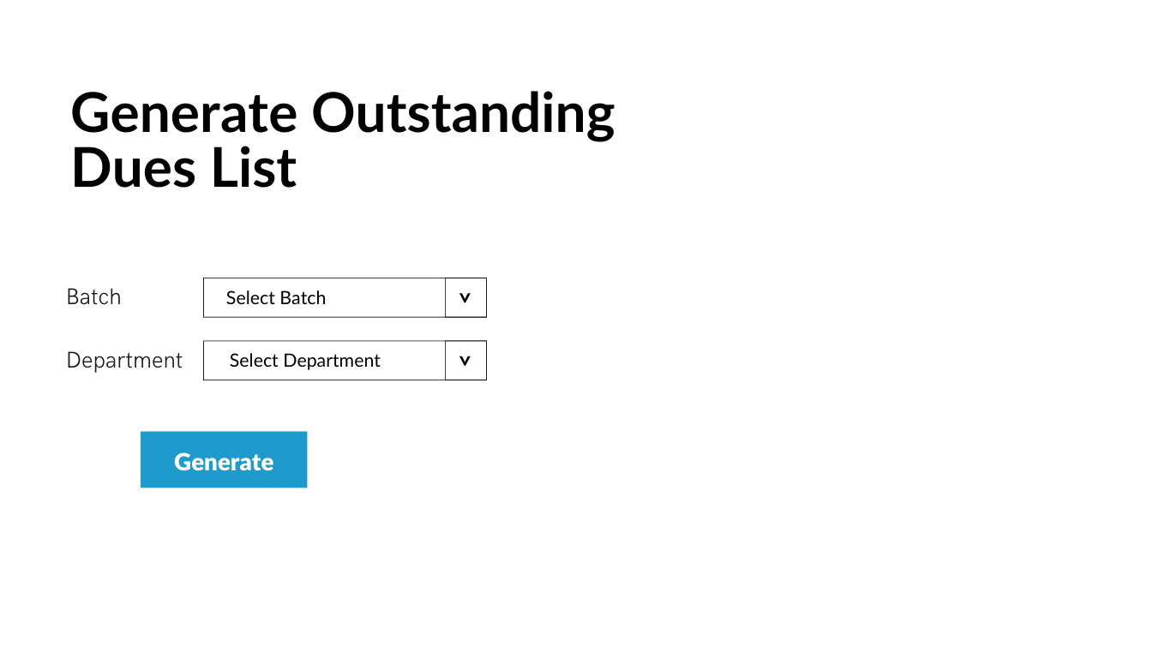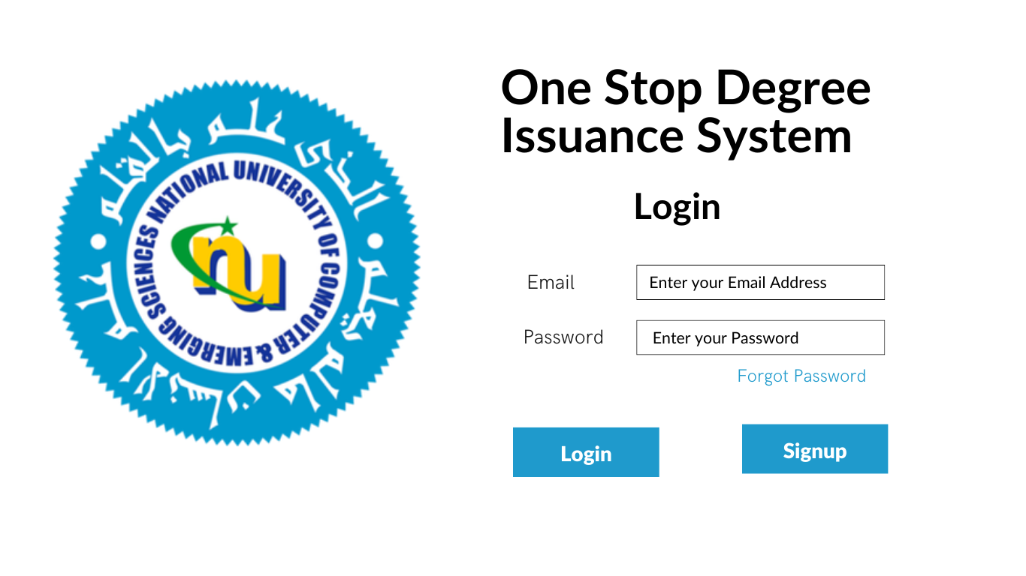

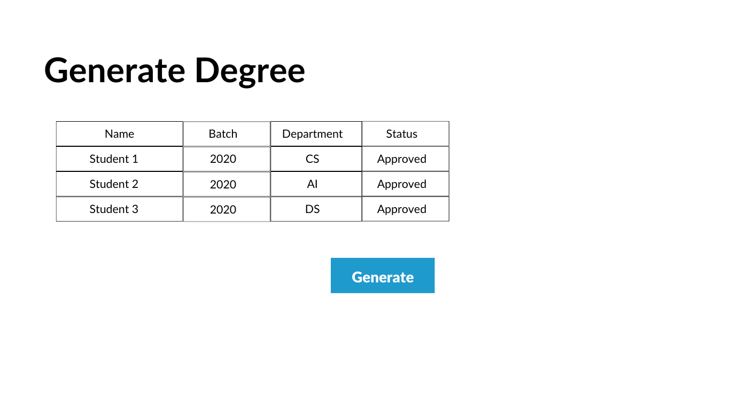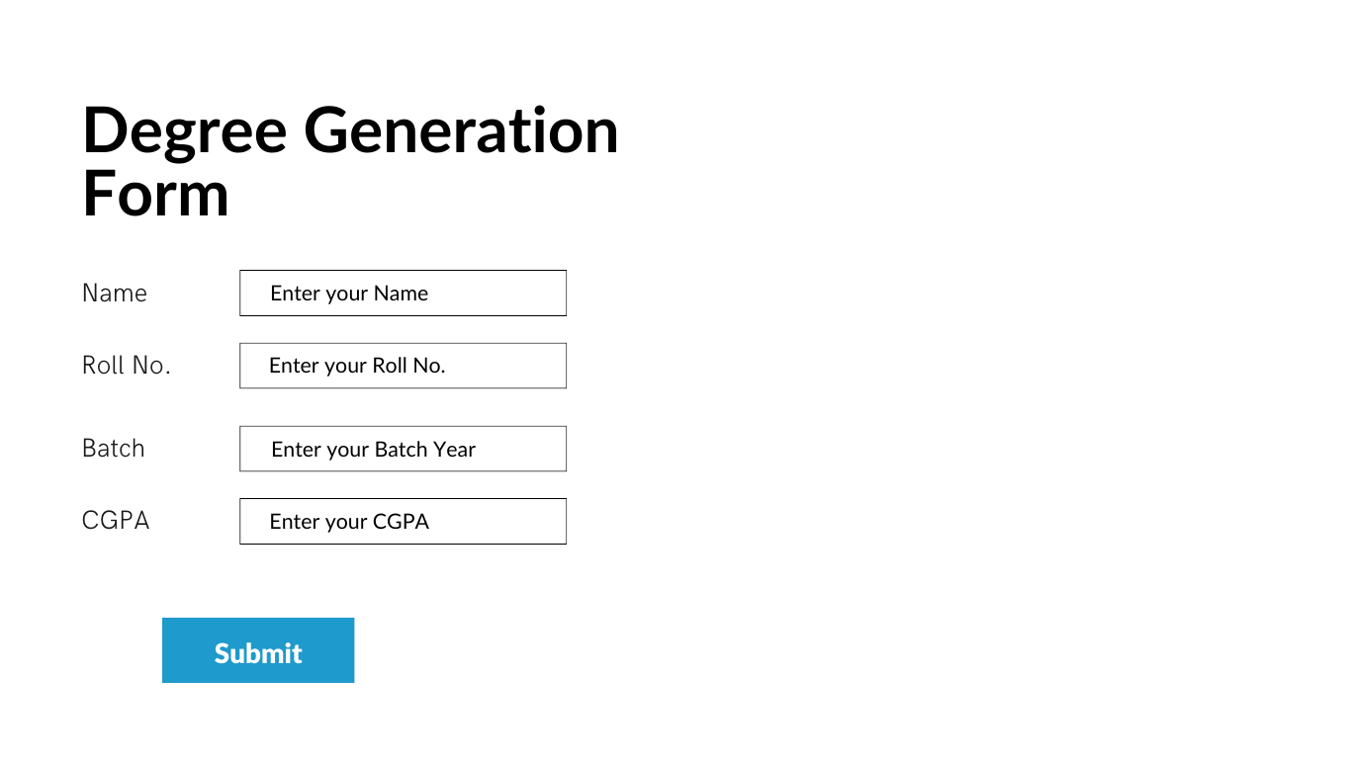

# Diagrams:

## Class Diagram:

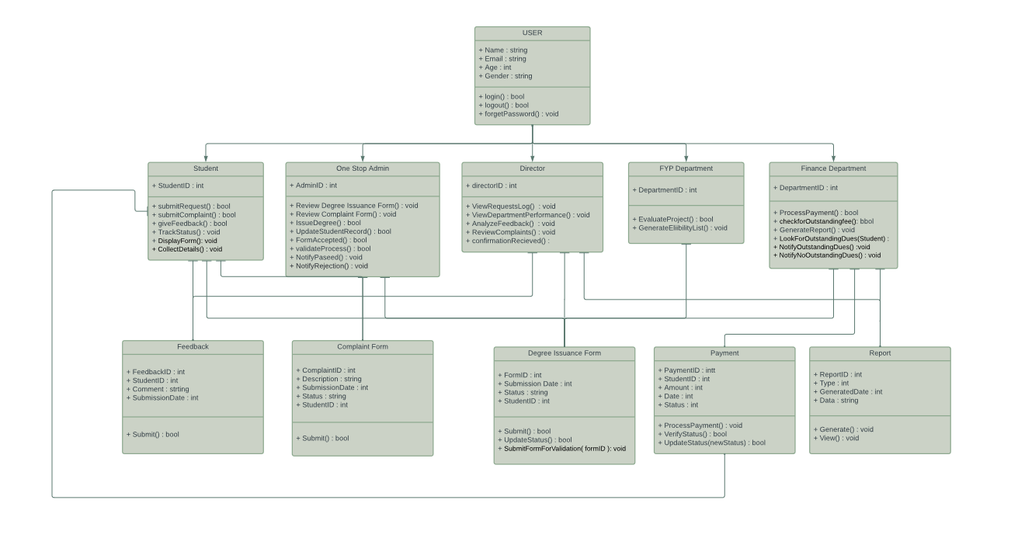

## Use Case Diagram:

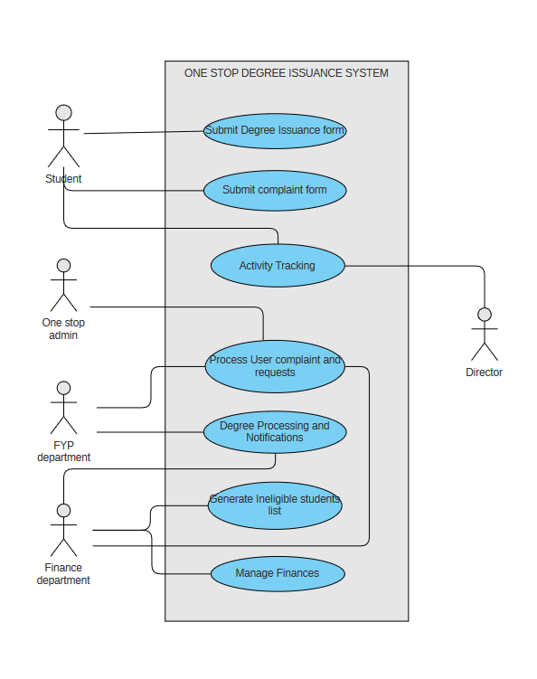

## Activity Diagram:

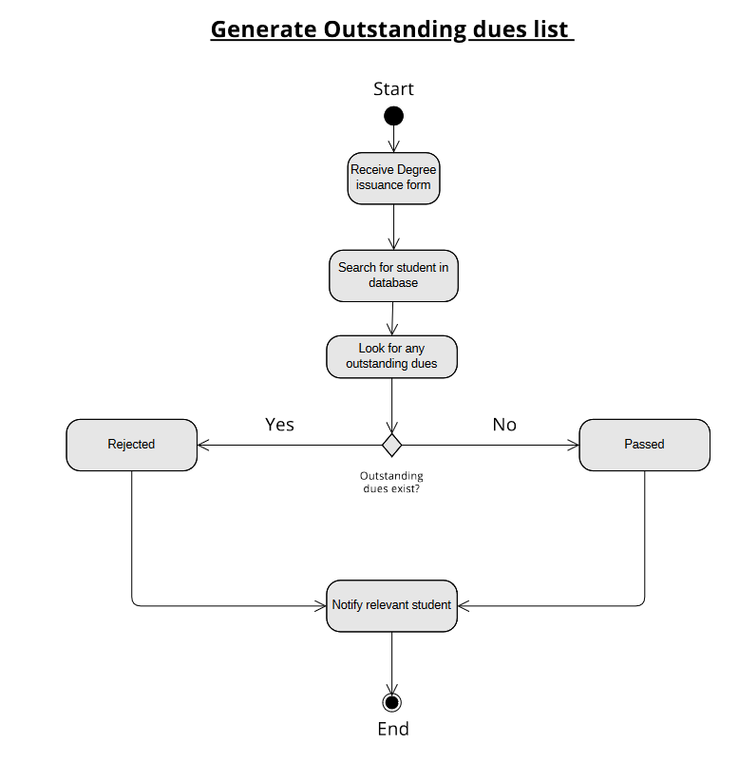

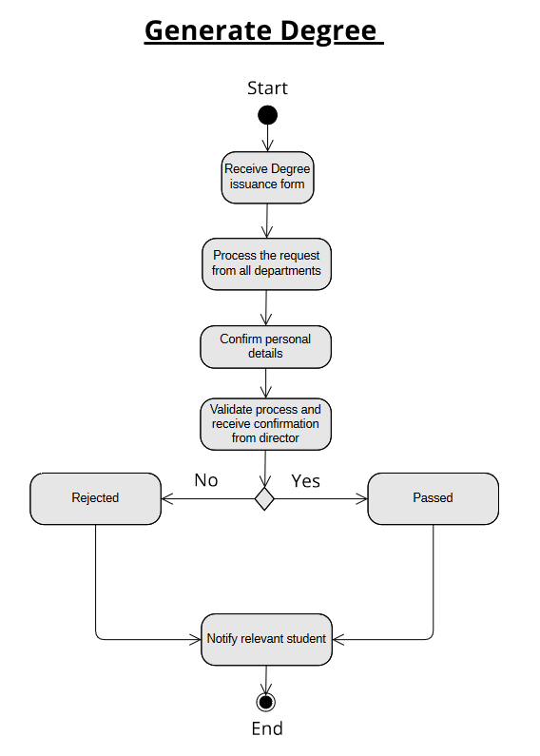

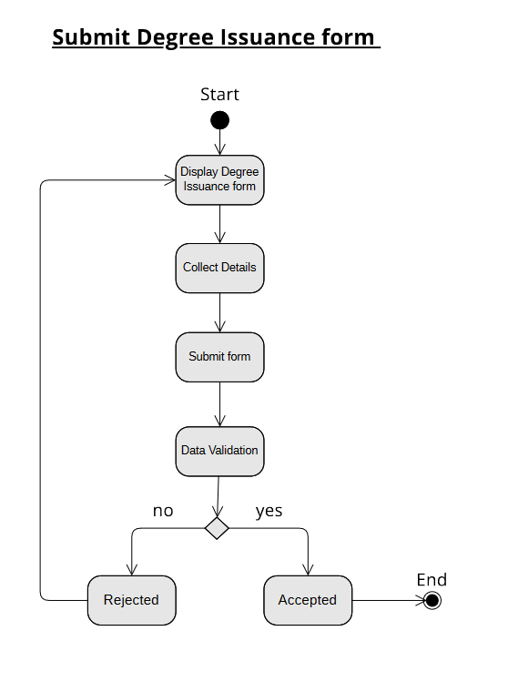

## Sequence Diagram:

### Submit Degree Issuance Form

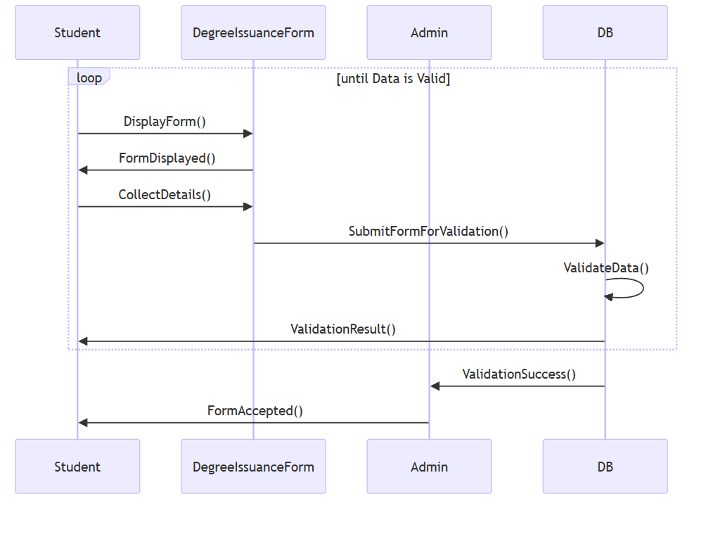

### Receive Degree Issuance Form

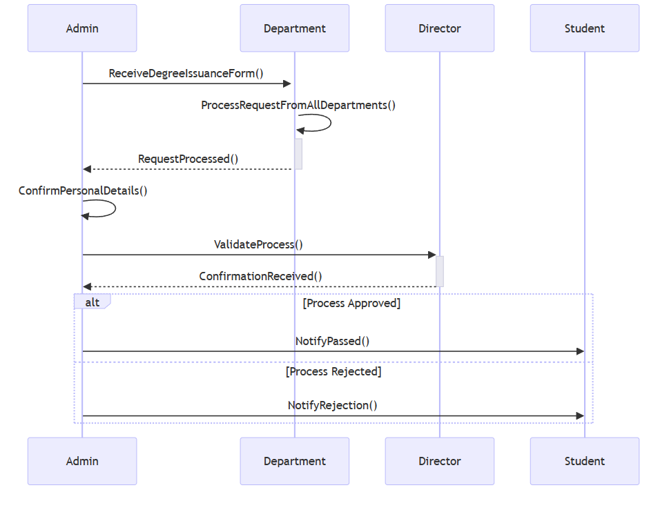

### Outstanding Fee

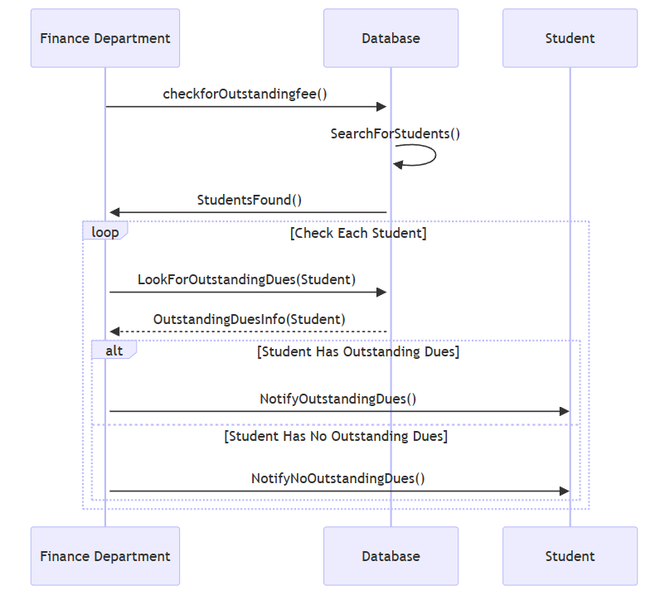

# Links:

**GitHub:**

<https://github.com/umairkhalidx/One-Stop-Degree-Issuance-System>

**Trello:**

<https://trello.com/invite/b/fq1hALcF/ATTI214e92d71c4b1df886a6b3c5d5b719ff4DD7B935/one-stop-degree-issuance-system>

# Snapshots:

## Snapshot 1

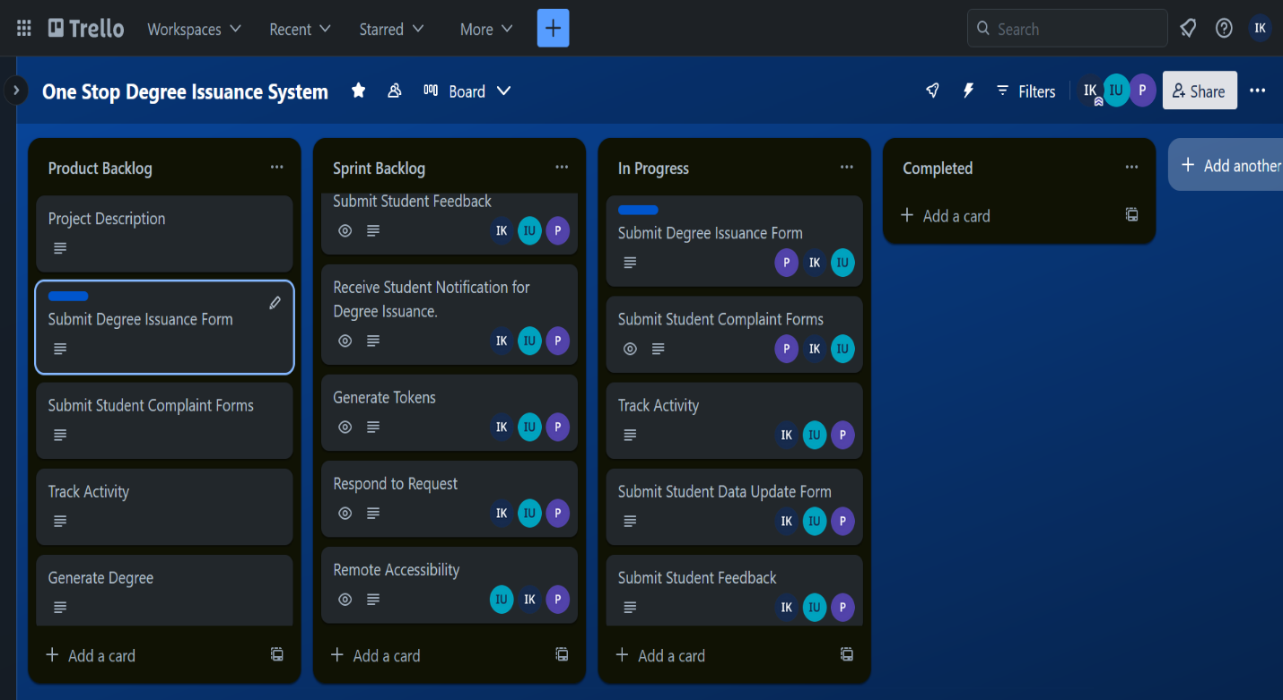

## Snapshot 2

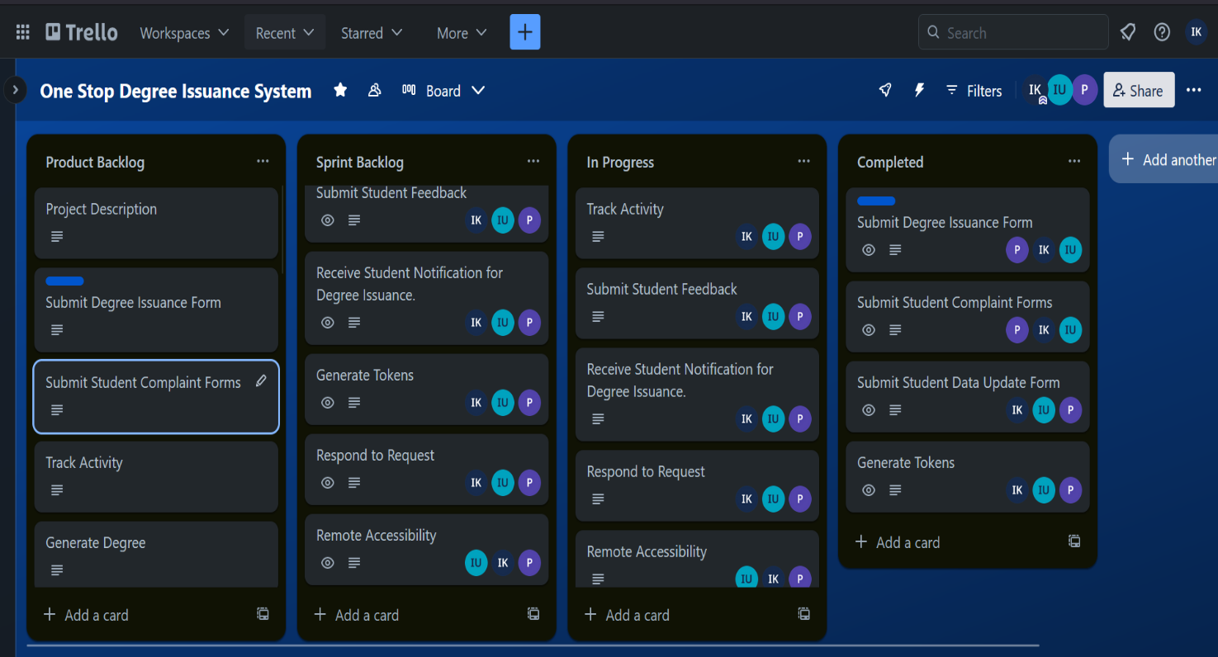

## Snapshot 3

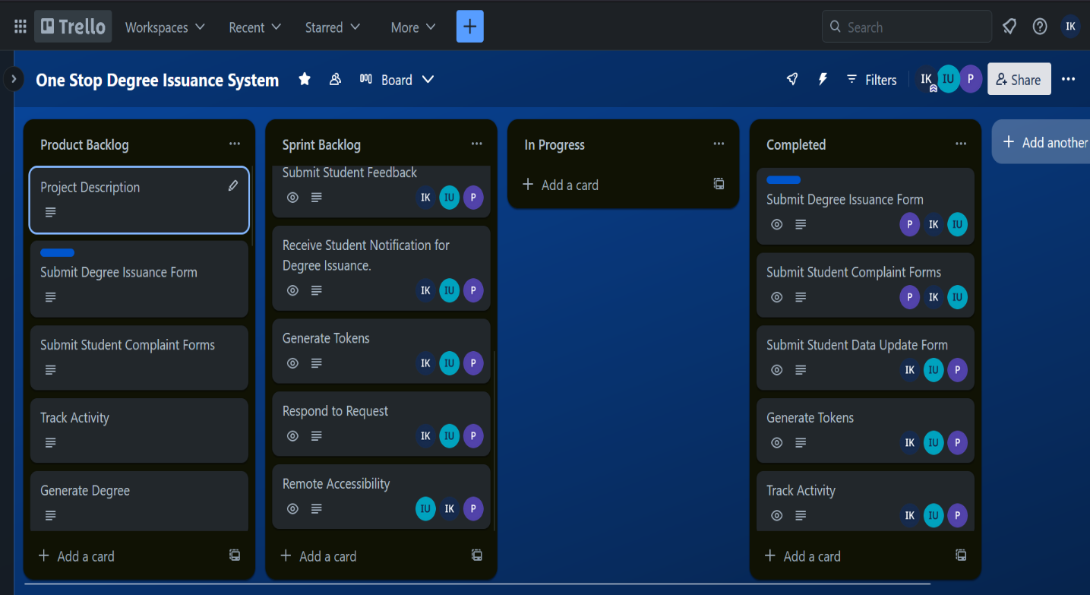

## Snapshot 4

